How to Download the Full Corpus?
- Click the link provided in our paper:
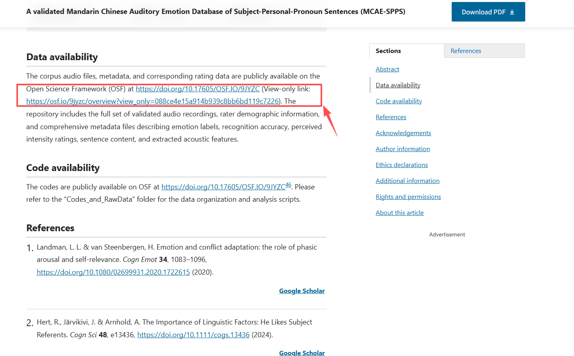

- You will be directed to our OSF database page. Click the Files button on the left side:
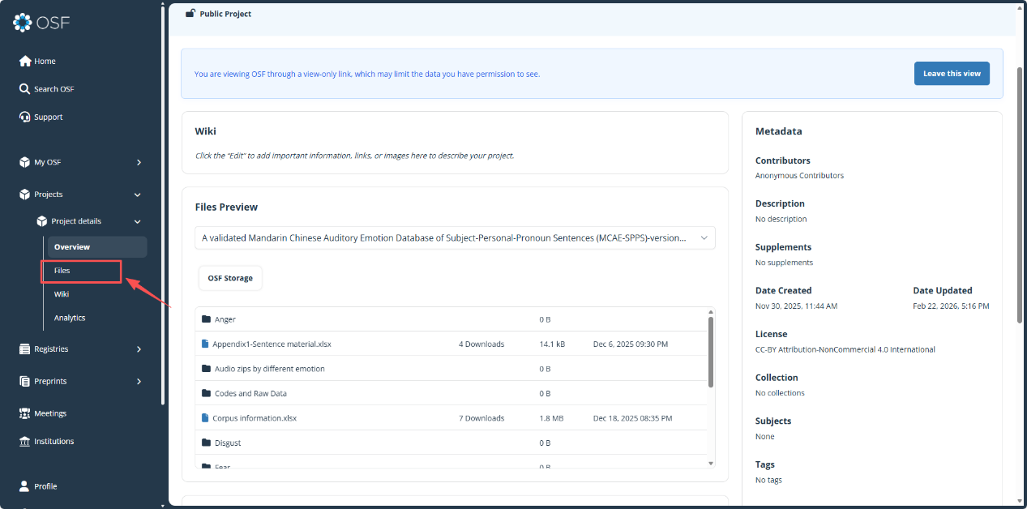
- You may select individual files to download. The Audio files folder can be downloaded as a zip archive, which contains the complete speech corpus.
Alternatively, you can click Download As Zip to obtain the entire corpus, including all raw data.
